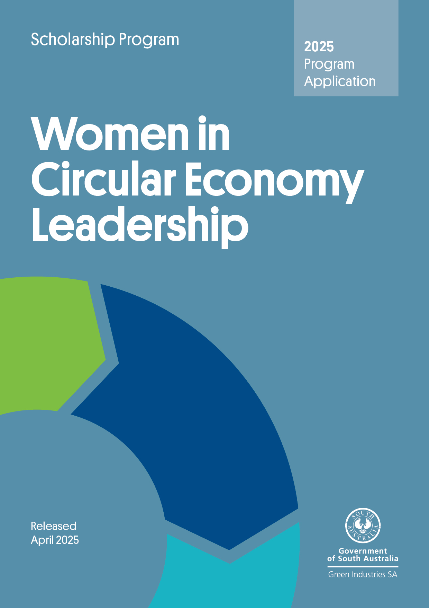

**Program overview**

The *Women in Circular Economy Leadership Scholarship* program aims to provide an opportunity for a South Australian woman who is an emerging leader working in the area of the circular economy to pursue an investigative project of a kind that is not readily available in South Australia.

**Submitting your application**

Applications will be accepted until5pm ACST, Friday 2 May 2025. **No late applications will be accepted.**

Please email your completed application form, with a signed declaration, including all supporting documents to [serena.yang@sa.gov.au](mailto:serena.yang@sa.gov.au) with the subject **line ‘Women in Circular Economy Leadership Scholarship – application’.** Emails should not exceed 10MB.

**Checklist**

Before submitting your application, please check you have completed all the following:

☐ Read the Women in Circular Economy Leadership Scholarship guidelines 2024–25 in detail

☐ Completed all relevant sections of the application form.

☐ Sign the declaration (ensure it is signed by an authorised officer)

☐ Attached all supporting documents.

**Need assistance?**

Contact Program Manager Serena Yang at [serena.yang@sa.gov.au](mailto:serena.yang@sa.gov.au) or on +61 8429 8435 for more information, or to check your eligibility.

**Section A: General applicant information**

|  |  |  |
| --- | --- | --- |
| A1. Personal details | | |
| Full name: | | |
| Date of birth: | | |
| **A2. Do you identify as Aboriginal or Torres Strait Islander** | | |
| ☐Yes ☐No ☐Prefernotto say | | |
| **A3. Residential and postal address** | | |
| Street address: | | |
| Suburb: State: Postcode: | | |
| Your postal address if different from your residential address | | |
| Street address: | | |
| Suburb: State: Postcode: | | |
| **A4. Primary contact details** | | |
| Email: |  | Mobile: |
| **A5. Employment details** | | |
| Current employment (if applicable) or previous employment (if relevant to your application): | | |
| Position (if applicable): | | |

**Section B: Eligibility criteria checklist**

|  |  |  |
| --- | --- | --- |
| **To be eligible for funding the applicant must meet all eligibility criteria below** | | |
|  | **Yes** | **No** |
| B1. Is the applicant an Australian citizen or permanent resident, and over the age of 18? | ☐ | ☐ |
| B2. Does the applicant live and work in South Australia? | ☐ | ☐ |
| B3. Does the applicant have experience in and commitment to the circular economy, and is not enrolled in tertiary studies directly related to the topic of the proposed project? | ☐ | ☐ |
| B4. Does the applicant have a detailed project plan outlining research methodologies and expected research outputs and outcomes? | ☐ | ☐ |
| B5. Is the applicant willing to disseminate the results of their project findings? | ☐ | ☐ |

**Applications that do not meet the above criteria will not be assessed further.**

**Section C: Project proposal**

|  |
| --- |
| **C1. Project title** |
|  |
| **C2. Project aim and ‘elevator pitch’ *(maximum 100 words)*** |
| *State the purpose or goal of your project. What is the relevance to Green Industries SA’s strategic priorities? Please start your project aim with a verb, such as “to investigate….”, ‘to research…”, “to study….” “to learn…”* |
| **C3. Project description *(maximum 1,000 words)*** |
| *Describe your project in clear, simple terms that will make it easy to comprehend. Be succinct and avoid jargon. Please explain project methodologies/approaches and intended project outputs and outcomes, including a brief description of the activities to be undertaken, such as interviews, site visits, observation, conference attendance, and so on.* |
| **C4. Project duration, proposed itinerary and project cost breakdown** |
| *Please specify your project duration/timeframe.*  *Please explain which places and organisations you would like to visit for your project and estimated dates. If an overseas trip is planned, please explain why you need to travel overseas to investigate your topic. High risk countries, as listed at* [*smarttraveller.com.au*](http://www.smarttraveller.com.au/)*, are to be avoided. Travel to these countries will not be approved.*  *Please be specific as possible and provide the associated estimated cost such as costs associated with travel, accommodation, attending conferences, disseminating project findings, and so on.* |

**Section D: Reasons for application**

|  |
| --- |
| **D1. Experience** |
| *List your experience and knowledge in the field of the project. What experience do you have to undertake the project? Please attach your CV and provide a link to your LinkedIn profile page.* |
| **D2. New knowledge and influencing change** |
| *What new knowledge do you hope to gain through this scholarship? How will you influence positive change and where? How will you share and disseminate your project findings with relevant stakeholders and the wider community?* |
| **D3. Community/industry benefits and circular economy relevance** |
| *How will your project benefit South Australia? How relevant is it to the circular economy? Are there broader benefits?* |

**Section E: Leadership**

|  |
| --- |
| **E1. Achievement** |
| *Working in the area of the circular economy what has been your proudest achievement in the last 5 years, and why? What did you learn along the way?* |
| **E2. Challenge** |
| *Working in the area of the circular economy, what has been the greatest test of your leadership, and how did you overcome it?* |

**Section F: References**

Please attach a written reference from a referee who can comment on your professional achievements and personal qualities, and provide an opinion regarding:

* the merit of the proposed project
* why the proposed project is necessary
* how the applicant and South Australia would benefit from the proposed project
* whether matched funding will be provided by the employer to support the application (optional).

Please include contact details (telephone numbers and email) of your referee.

**Section G: Declaration**

**Declaration**

* I have read and understood the guidelines and obtained clarification where needed.
* I declare that the information provided in this application including attachments is true and correct and discloses all required and relevant details. I understand that if information supplied as part of the application is false or misleading in a material particular, the application will not be considered OR, if the grant is made and it is discovered that information supplied was false or misleading in a material particular, the grant will be revoked and funds, plus interest, must be repaid. An assessment regarding possible fraud will also be undertaken and appropriate legal action initiated if warranted.
* I declare that I have complied with federal and state laws, regulations, and the Environment Protection Authority licences (if any).
* I authorise Green Industries SA to seek any additional relevant information required to process this application, and I/we hereby request and authorise any parties to supply such information as requested.
* I understand that if the project is approved for funding, information about the project may be publicised by Green Industries SA or provided as required or permitted by law.
* If the project is approved for funding, I will obtain all necessary and appropriate clearances from the relevant Commonwealth, state or local governments before executing the grant agreement and undertake to manage the proposed project in accordance with relevant laws and regulations.
* If I accept an offer of funding, then I accept (jointly and severally in the case of a group application) responsibility for administering grant funds and liability in the event grant funds are to be repaid.

|  |  |  |
| --- | --- | --- |
| Signed |  |  |
| Name |  |  |
| Date |  |  |